

2007成都“ 大熊猫家园之旅”
2007 Chengdu "panda homeland trip"

（北京行程暂定）
时间Time | 活动内容Itinerary
第一天The First Day  7/2/07 | 从纽约 JFK 国际机场乘中国国际航空公司飞机直飞北京Depart from NYC JFK to Beijing on board of Air China
第二天The Second Day  7/3/07 | 抵达北京转机飞成都，入住酒店  Arrival at Beijing | 晚上：到达酒店， 休息  Night: Staying in the hotel, and resting
第三天  7/4/07 | 9:00-11:30：成都大熊猫繁育基地，开营仪式，  分发营服，胸牌、熊猫标志.介绍  夏令营具体安排，营员互相认识  Camp Opening Ceremony at Chengdu  Great Panda Breeding Base including  the distribution of the name tag,  the camp uniform, the panda logo,  introduction of the camp, and the members of the camp  12:00： 午餐Lunch | 13:30-17:00：观看反映大熊猫过去、现在和未  来的科教片；参观大小熊猫活动场  Watch the documentary film of the great panda’s past, present and future. Tour to the great panda’s activity field    17:30： 晚餐Supper
第四天  7/5/07 | 9:00 – 11:30: 参观兽舍、大熊猫产房，观察大熊猫  生活习性并作观察记录，与大熊猫合影留念  Tour the great panda’s dormitory, delivery room, take the observation of the great panda’s habits and make records, take pictures with the great panda  12:00：午餐Lunch  13:30-15:30：游览天鹅湖，了解天鹅习性  Tour the Lake Swan to understand the swan’s habits | 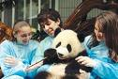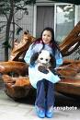  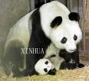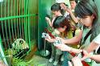  18:00 晚餐 营员排练节目Rehearse the  play for the Camp Closing  Ceremony
第五天  7/6/07 | 9:00 – 11:30：参观熊猫博物馆，蝴蝶博物馆，  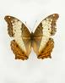  近距离亲近大熊猫，听动物专家讲解有关大熊猫 的知识Visit the Great Panda Museum, the Butterfly Museum, the opportunity to touch the great panda, listen to the zoologist about the great panda | 12:00： 午餐Lunch  13:30-17:00: 观看民间艺人现场进行熊猫剪纸及  但刻画技艺表演，学习剪纸、画作  Watch the folk artist to perform the paper cutting & carving. Learn how to do these Chinese folk arts  17:30：晚餐 营员排练节目Rehearse the play  for the Camp Closing  Ceremony
第六天  7/7/07 | 9:00 – 17:00：前往大熊猫野外息栖地，了解大熊  猫野外生长环境并参观熊猫艺术博  物馆和生态博物馆 Tour in the wild habitant for the great panda, visit the Great Panda Museum of Art and the Great Panda Museum of Ecology  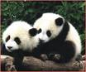 | 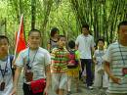  16:30：住宿家庭家长来体育中心接营员，在住宿  家庭晚餐the Camper are picked up by the host family and dinner with the host family
第七天  7/8/07 | 9:00-11:30:与成都中学生联谊，开展以“人与  自然”为主题的活动，内容包括：  漫画、表演、体验游戏、知识竞赛Party with the local students. The topic is “the Nature and the Man”, includes Graffiti, performance, games and knowledge contests  12:00： 午餐(必胜客)Lunch at Pizza Hut   | 13:30-16:00：游览清代旗人居住地-宽、窄巷子，  并进行老成都游戏，如：滚铁环、  打弹子等  Tour the habitant of the Manchurian in Qing Dynasty: the Broad and narrow lane, have Chengdu old games such as Gun-Tie-Huan  晚上：住宿家庭家长来体育中心接营员，在住宿  家庭晚餐the Camper are picked up by the host family and dinner with the host family
第八天  7/9/07 | 9:30-11-30：学习四川皮影戏的制作（中文日常  用语学习）Learn the letter-silhouette show and study the daily chinese  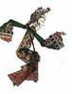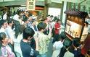  12:00： 午餐（成都地方小吃）Lunch: famous Chengdu Local Dim Sium | 13:-17:30：游览黄龙溪古镇，了解川西固镇的  古街坊、古寺庙、古建筑民居、古  树等景致  Tour the ancient town, Yellow-Dragon Zhen  晚上：住宿家庭家长来体育中心接营员，在住  宿家庭晚餐the Camper are picked up by the host family and dinner with the host family
第九天  7/10/07 | 9:30-11:30： 了解中国传统节目的风俗习惯并  学习中国书法  Understand the Chinese folk festival habits and learn the Chinese calligraphy  11:30- 14:30: 前往具有浓郁中国文化气息的皇  城老妈火锅城参观并自助火锅  Buffet at the famous and historical pot restaurant, Dynasty Grandma, for lunch  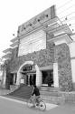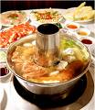  著名的皇城老妈火锅店 | 15:00-17:00：参观成都的中学，了解中国学生  的学习环境和课程设置Visit a local middle school and understand the Chinese school and the curricular  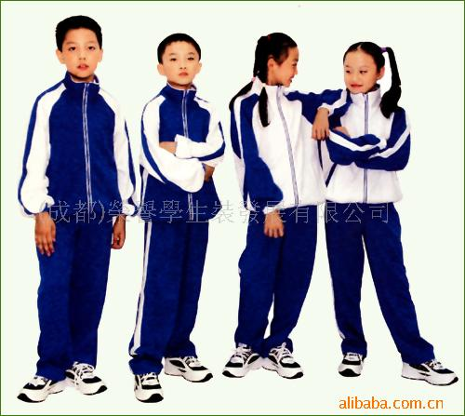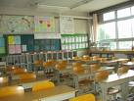  晚上：住宿家庭家长来体育中心接营员，在住  宿家庭晚餐the Camper are picked up by the host family and dinner with the host family
第十天  7/11/07 | 9:00-11:30： 与成都青少年共登新津老君山Climb the Mount Xinjin Laojing with the local students  12:00-13:00：在新津午餐Lunch at Xinjin  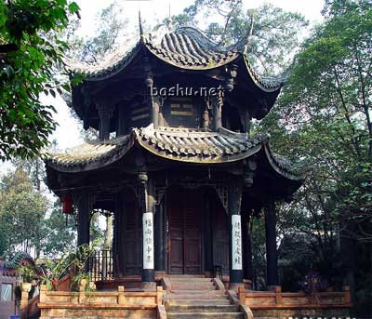  老君山 花卉博览会 | 13:30-17:30：游览温江花卉博览会公园，欣赏  来自世界各地的珍稀花卉和植物  Tour Wenjiang Butanic Garden and Museum to appreciate the flowers and plants from all over the world  晚上：住宿家庭家长来体育中心接营员，在住  宿家庭晚餐the Camper are picked up by the host family and dinner with the host family
第十一天  7/12/07 | 9:00 – 17:30： 上午、下午：前往峨眉山世界  第一大佛也是有“世界文化与自然遗产”之称的乐山大佛参观、游玩Tour and climb the Mount Ermei and visit the largest Buda, Le Shan Buda, which is also the world heritage  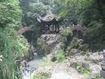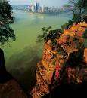 | 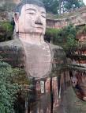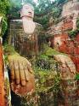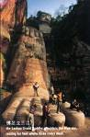  晚上：住宿家庭家长来体育中心接营员，在住宿  家庭晚餐  the Camper are picked up by the host family and dinner with the  host family
第十二天  7/13/05 | 9:30-11:30：上午：中国历史故事课并学习相  关中文词句Morning: Chinese history lesson and Chinese learning  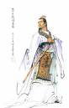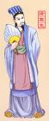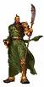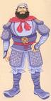  三国演义人物Three Kingdom’s Figures  12:00：午餐Lunch | 13:00-17:30：参观武侯祠博物馆，了解三国人  物，游览川西老街一景里步行街  Visit Jugeliang Museum and understand the figures in the Three Kingdoms and their stories  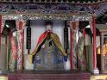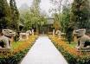  诸葛亮Jugeliang 武侯祠Wuhou Temple  晚上：住宿家庭家长来体育中心接营员，在住宿  家庭晚餐the Camper are picked up by the host family and dinner with the host family
第十三天  7/14/05 | 9:00-16:00：参观世界文化遗产-都江堰水利工程  Visit the world’s heritage, Dujiangyan  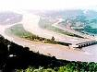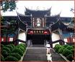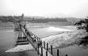  主要景点包括：伏龙观、二王庙、安澜索桥等；之后前往青城山，熏染道教文化includes the sceneries of Fulongguang, Two Kings Temple, Anlan Bridge | 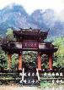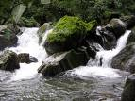  青城山  晚上：住宿家庭家长来体育中心接营员，在住宿  家庭晚餐the Camper are picked up by the host family and dinner with the host family
第十四天  7/15/05 | 9:30-11:30：中国饮食文化课。并教学生们制作  一至两个有特色的川菜  Lesson for the Chinese cuisine  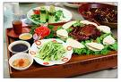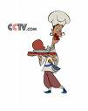  12:00： 午餐Lunch | 1:30-17:00：金沙博物馆Jinsha Museum of Sanxingdui  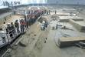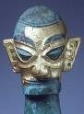  金沙遗址Relics of Jinsha 金面人头像Golden Lion Face  晚上：住宿家庭家长来体育中心接营员，在住宿  家庭晚餐the Camper are picked up by the host family and dinner with the host family
第十五天  7/16/05 | 9:30-11:30：中国民族音乐欣赏课，其后分为两  组分别学习传统功夫太极拳和民族  舞蹈Appreciation of Chinese Folk Music, learn Taiqi Kungfu and Folk Dance  12:00-14:00: 午餐、休息Lunch and resting | 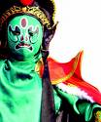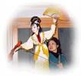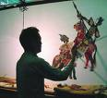  14:30-16:30：观看川剧变脸、木偶、皮影戏、  杂技等独具成都特色的文艺表演Watch the Folk Drama: Facial Changes, letter-silhouette, wooden-image
第十六天7/17/05 | 修整，和住宿家庭告别。  Packing and farewell to the host family | 16:00-17:30：在户外进行体育活动。  晚上：回酒店休息Outdoor sports and resting at the hotel
第十七天  7/18/05 | 9:30-11-30：分组排练，练习太极拳和民族舞蹈  Practicing: Taiqi Kungfu and Folk Dance  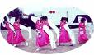  12:00： 午餐Lunch  14:00-17:30：在杜蒲草堂，进行中外青少年艺术  交流表演The performance at Dupu Straw Temple with the campers and the local students | 18:00： 欢送宴会，每位团员将获赠主办单位精心准备的礼物（熊猫体恤集成都小画册）  （寄宿家庭代表参加）  The Camp Closing Ceremony  each camper awarded a meaningful gift  from the organizer: the great panda T-shirt  and a album of the Chengdu City  (Host Family invited)
第十八天7/19/05 | 上午：送机场乘飞机前往北京  Depart to Beijing  北京接机后参观天安门夜景，晚餐后入住酒店。  and after dinner go to hotel | 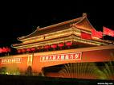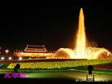
第十九天  7/20/05 | 游览世界上最大的城市广场—天安门广场  Tour the Tian An Men Square  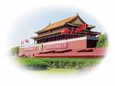  the Tian An Men Square  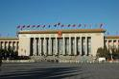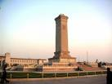  观庄严的人民大会堂外景，雄伟壮观的人民英雄纪念碑 | 午餐后登上雄伟壮观的八达岭长城，领略“不到长城非好汉”的气魄。  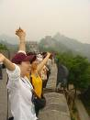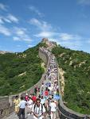  长城  The Great Wall
第二十天  7/21/05 | 上午：参观中国现存规模最大最完整的古代帝王建筑群—故宫  Tour the Forbidden Palace  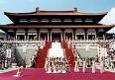  故宫  The Forbidden Palace | 午餐后胡同参观及学生家庭访问（学包饺子）  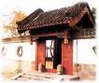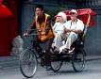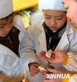  the Beijing Hutong
第二十一天  7/22/05 | 上午：整理行装 Packing  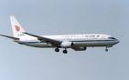  下午：北京机场，乘飞机回纽约 Depart for New York | 下午：2:30 抵达JFK机场，家长机场迎接  2:30 pm arrival at JFK and picked up by the parents. The Camper successfully ends  

