Tai Chi Demo and Classes
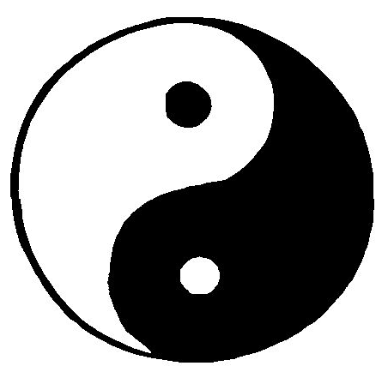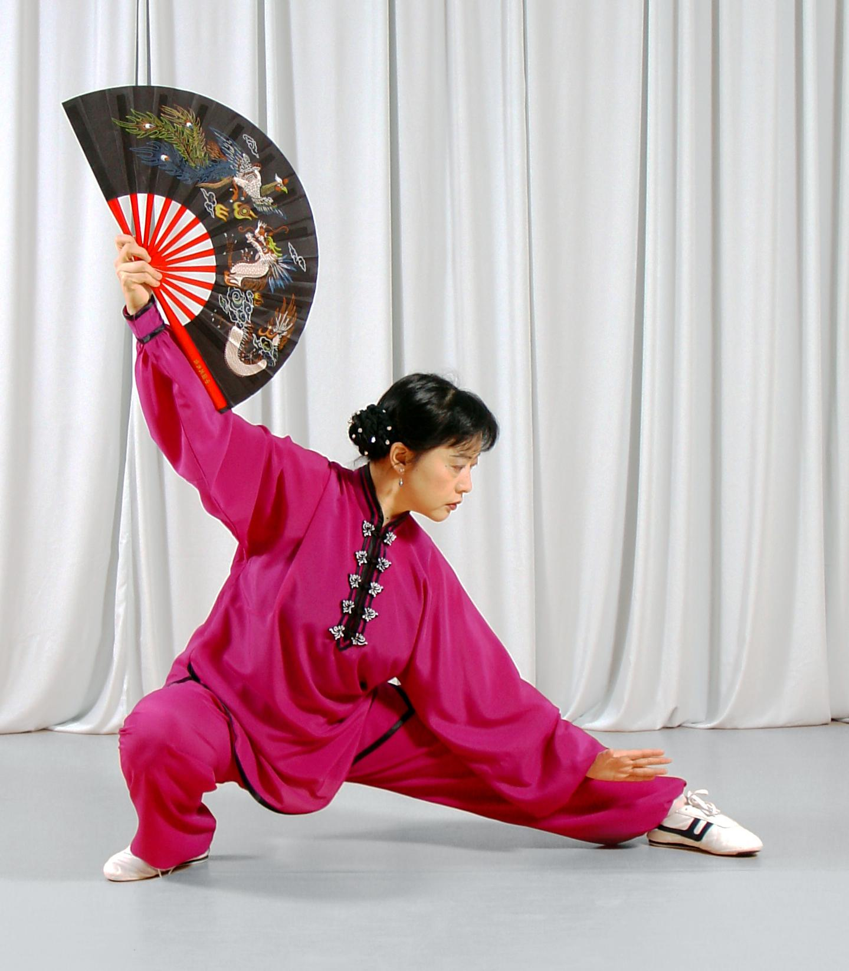

Teacher: Master Zhang (張桂芳); Contact: 732-754-9774 (中文); 732-986-1298 (Eng.)
Where: 华硕文化教育学院 (Hua Shuo Education School)
450 Division Street, Edison, NJ 08817

Demo Time: 3 p.m., Saturday, May 8th.
Tai Chi Classes:
- Time: To be determined at registration (Optional schedule: Sat. & Sun. pm; starts from September, 2010)
- Cost: $15 per lesson
- Promotion: $12 per lesson (Register at 20% discount with this flyer)
- Courses:
Level I (Basic): 24 forms of simplified Yang style Tai Chi
Level II (Advanced): 42 forms of Tai Chi Competition Routine
Others: Kung Fu Fan, Tai Chi Sword, etc.

About Master Chang:
Master Chang began learning Tai Chi when she was young. She has won a title of Tai Chi Championship and several medals in International Tai Chi competition events in China. She held a sixth degree certificate of National Martial Art in China. She was ranked as the first class of National certified Tai Chi coach and judge in China. She has been a member of Martial Art Association in Chin-Dao city, China. She is very knowledgeable in Tai Chi and is able to teach a variety of Tai Chi competition forms including Tai Chi Chuan, Sword and Kung Fu Fan. Master Chang has many years of Tai Chi teaching experience and has taught more than thousand of students in China. Since she immigrated to USA six years ago, she has taught many students in Edison, New Jersey.

Benefit of Practicing Tai Chi:
Tai Chi is an ancient Chinese martial art. Today, Tai Chi practice is very popular all over the world for its combating skills and as an aid to improve physical fitness. Tai Chi is practiced in a form of slow, gentle movement of the arms, legs and torso. Tai Chi practitioners learn to relax their mind and body through the harmony movement to strengthen their overall mental and physical awareness. Daily practice of Tai Chi has been shown to have beneficial impact on reducing stress and improving the quality of life. Tai Chi exercise is suitable for children and adults.

